Mar 2026 51.511 Multimodal Generative AI Project Proposal
Agentic Expense Claims - A Multi-Agent Multimodal System for Automated Expense Report Processing

Prepared by
Nguyen Thanh Tung (1011011)
Josiah Lau (1001530)
James Oon (1010718)
Sagar Pratap Singh (1010736)

1. Problem Decomposition

1.1 Problem Statement
The expense claim process in many corporate including SUTD using SAP Concur contains operational inefficiencies for both students and administrative reviewers. Reimbursements may take up to two months due to multiple validation stages, manual data entry, policy interpretation challenges, and repeated claim resubmissions that often lead to errors and claim rejections.
1.2 Current Workflow Pain Points
The current workflow faces several inefficiencies, including OCR errors in receipt extraction, time-consuming manual data entry, and complex policy rules with numerous GL codes. These issues frequently lead to claim rejections, require manual cross-checking of multimodal documents (receipts, PDFs, itineraries), and provide no real-time validation before submission.
1.3 Sub-Task Decomposition
The proposed workflow decomposes the process into four agent nodes orchestrated through a shared state: multimodal data extraction using vision-language models, policy compliance validation using retrieval-augmented reasoning, and parallel compliance and fraud detection checks. A final risk-based routing node aggregates the results and conditionally directs the claim toward automated approval, correction requests, or human review. These stages cannot be merged into a single model invocation because they require different models (VLM for image understanding, LLM for policy reasoning), different external tools (database queries, currency APIs, email notifications), and different reasoning contexts (claimant-facing validation vs. organizational audit vs. risk assessment).
2 Agent Architecture
The system exposes a Chainlit-based conversational interface supporting two user personas:
Claimant persona- Interacts with the Intake Agent via image uploads and text input. The agent guides claim preparation, flags policy violations, and iterates until all pre-submission checks pass.
Reviewer persona- Receives escalated claims with the Advisor Agent's risk summary, compliance and fraud findings, and cited policy clauses. Can approve, reject, or return the claim with comments.

2.1 System Diagram
Figure 1 presents a four-agent pipeline orchestrated by LangGraph, separated into pre-submission and post-submission stages. Pre-submission, the Intake Agent guides the claimant through receipt extraction and policy validation. Post-submission, the Compliance and Fraud Agents assess the claim in parallel, and the Advisor Agent synthesizes their findings to auto-approve, return, or escalate to human review.
2.2 Agent Roles
The system is built on LangGraph, which acts as the multi-agent orchestrator, with each nodes hosting one or more agentic processes as part of the claim expense workflow:
Agent | Agentic Pattern | Serves | Responsibility
Intake Agent | ReAct + Evaluator Gate | Claimant | Guides the claimant through expense submission via a conversational loop, extracting receipt data, validating against policy rules, converting currencies, and persisting the claim until all pre-submission checks pass.
Compliance Agent | Evaluator | System | Audits the submitted claim against organizational policies — budgets, spending limits, and approval thresholds — producing a structured pass/fail compliance finding with cited policy clauses.
Fraud Agent | Tool call | System | Checks the submitted claim for fraudulent nature of receipts, anomaly detection or duplicate receipts by querying historical claims in the database. Returns a fraud/legit finding per receipt.
Advisor Agent | Reflection + Routing | Reviewer | Synthesizes compliance and fraud findings into a risk assessment via reflection, then routes the claim to auto-approve, return to claimant, or escalate to human reviewer with policy citations.
2.3 Model and Tool Choices Orchestration: LangGraph.
The workflow requires conditional branching, parallel execution, iterative loops, and shared state passing between agents. LangGraph models these natively as a state machine with explicit graph nodes and edges — supporting ReAct via create_react_agent, routing via conditional edges, and parallelization via fan-out/fan-in — without requiring an additional agentic SDK.
Vision-Language Model — Candidate: GLM-4.6V; Alternative: Qwen2.5-VL-7B-Instruct.
The VLM is responsible for extracting structured fields from receipt images natively, without a separate OCR pipeline. GLM-4.6V is the primary candidate for its MoE architecture and deep document reasoning capability. Qwen2.5-VL-7B-Instruct is the self-hostable alternative with strong OCR performance. Final selection will be based on extraction accuracy, inference latency, and hardware feasibility.
LLM for Reasoning Agents — Candidate: GLM-5; Alternative: Qwen2.5-7B-Instruct.
The LLM drives text-based reasoning across the Compliance, Fraud, and Advisor agents over policy documents and structured data. GLM-5 is the primary candidate for its frontier agentic reasoning and 200K context window, accessed via API. Qwen2.5-7B-Instruct is the self-hostable alternative that eliminates API dependency. Final selection will be based on reasoning quality, interactive latency, and cost of operation.
MCP Server | Used By | Purpose
RAG MCP  (rag-mcp-server) | Intake Agent,  Compliance Agent | Retrieves relevant policy clauses from institutional knowledge base
DBHub MCP | Intake Agent,  Fraud Agent | Provides database access via Postgres to retrieve and store structured data (save expense claims, retrieve historical claims)
Frankfurter MCP | Intake Agent | Converts foreign currency amounts to SGD using live exchange rates
Email MCP | Advisor Agent | Sends notification emails to claimants (returns, status updates), and reviewers (escalations)
3 Multimodal Grounding
3.1 Modalities Used
The system processes three modalities across the agent pipeline:
- Image — Receipt images processed by a VLM to extract structured fields. Candidates: GLM-4.6V-Flash (9B) or Qwen2.5-VL-7B-Instruct.
- Text — Policy documents, claim descriptions, and reviewer notes validated via RAG. Candidates: GLM-5 or Qwen2.5-7B-Instruct.
- Structured Data — Historical claims, budgets, and currency rates accessed via MCP tool calls. Model-agnostic.

3.2 Cross-Modal Interaction
Each agent grounds outputs from the previous stage across modalities:
- Intake Agent — Grounds image-extracted fields against claimant text; flags inconsistencies and returns low-confidence extractions for clarification.
- Compliance Agent — Grounds retrieved policy text against structured claim output; produces a pass/fail finding with cited policy clauses.
- Fraud Agent — Cross-references claim against historical records for duplicates, anomalies, and vendor irregularities; preserves uncertainty rather than forcing a binary outcome.
- Advisor Agent — Synthesizes extraction confidence, compliance findings, and fraud signals into a unified risk assessment; escalates to human review on agent disagreement.
No single modality drives the final decision. Final model selection between GLM and Qwen2.5 candidates will be determined during solution architecture validation.

4 Control and Failure Handling
4.1 Error Detection Mechanisms
The system detects uncertainty at each agent stage rather than treating claims as a single end-to-end prediction. The Intake Agent checks for unreadable receipts, missing fields, inconsistent values, and low-confidence extractions, returning incomplete claims to the claimant before submission. Post-submission, the Compliance Agent audits policy rules and approval conditions via RAG, while the Fraud Agent screens for duplicates and anomalies via DBHub MCP in parallel. The Advisor Agent combines both outputs and routes the claim to auto-approve, return, or human escalation.

4.2 Retry, Self-Critique, and Fallback Strategies
Each agent applies bounded retry with conservative fallback. The Intake Agent retries up to a fixed limit before returning to the claimant. The Compliance Agent iterates via an evaluator until the outcome is clear or no longer improving. The Fraud Agent forwards uncertainty rather than forcing a flag on weak evidence. The Advisor Agent reflects before routing, automating only when evidence is sufficient. On tool failure, the system degrades gracefully: failed VLM triggers resubmission, weak RAG leads to conservative routing, and unresolved DB checks are treated as uncertain.

5 Evaluation Strategy (Preliminary)

5.1 Task-Specific Success Criteria
Metric | Target | Measurement Method
Submission time | < 3 min (vs. 15-25 min) | The average time from receipt upload to completed claim submission during a controlled user study with students submitting sample claims.
Accuracy | > 95% on structured fields | Evaluate field-level accuracy
5.2 Baselines
The system is evaluated against two baselines: (1) a single-prompt pipeline using a general-purpose model Gemini, and (2) the current manual SAP Concur workflow. Comparison targets extraction accuracy, automation rate, and workflow efficiency.
5.3 Failure Analysis
System limitations are identified using self-consistency checks, cross-modal agreement checks, verifier models, and inter-agent disagreement analysis across extraction, policy reasoning, and coordination failures.
6 Reflection
6.1 When Agentic Behavior is Beneficial
Expense claim processing spans perception, policy interpretation, and financial validation — steps that require different models, tools, and reasoning contexts that cannot be collapsed into a single model invocation reliably.
6.2 Limitations
Known limitations include OCR inaccuracies on poor-quality receipts, policy drift requiring continuous knowledge base updates, multi-agent coordination overhead, and irreducible human oversight for ambiguous or high-risk claims.

REFERENCES
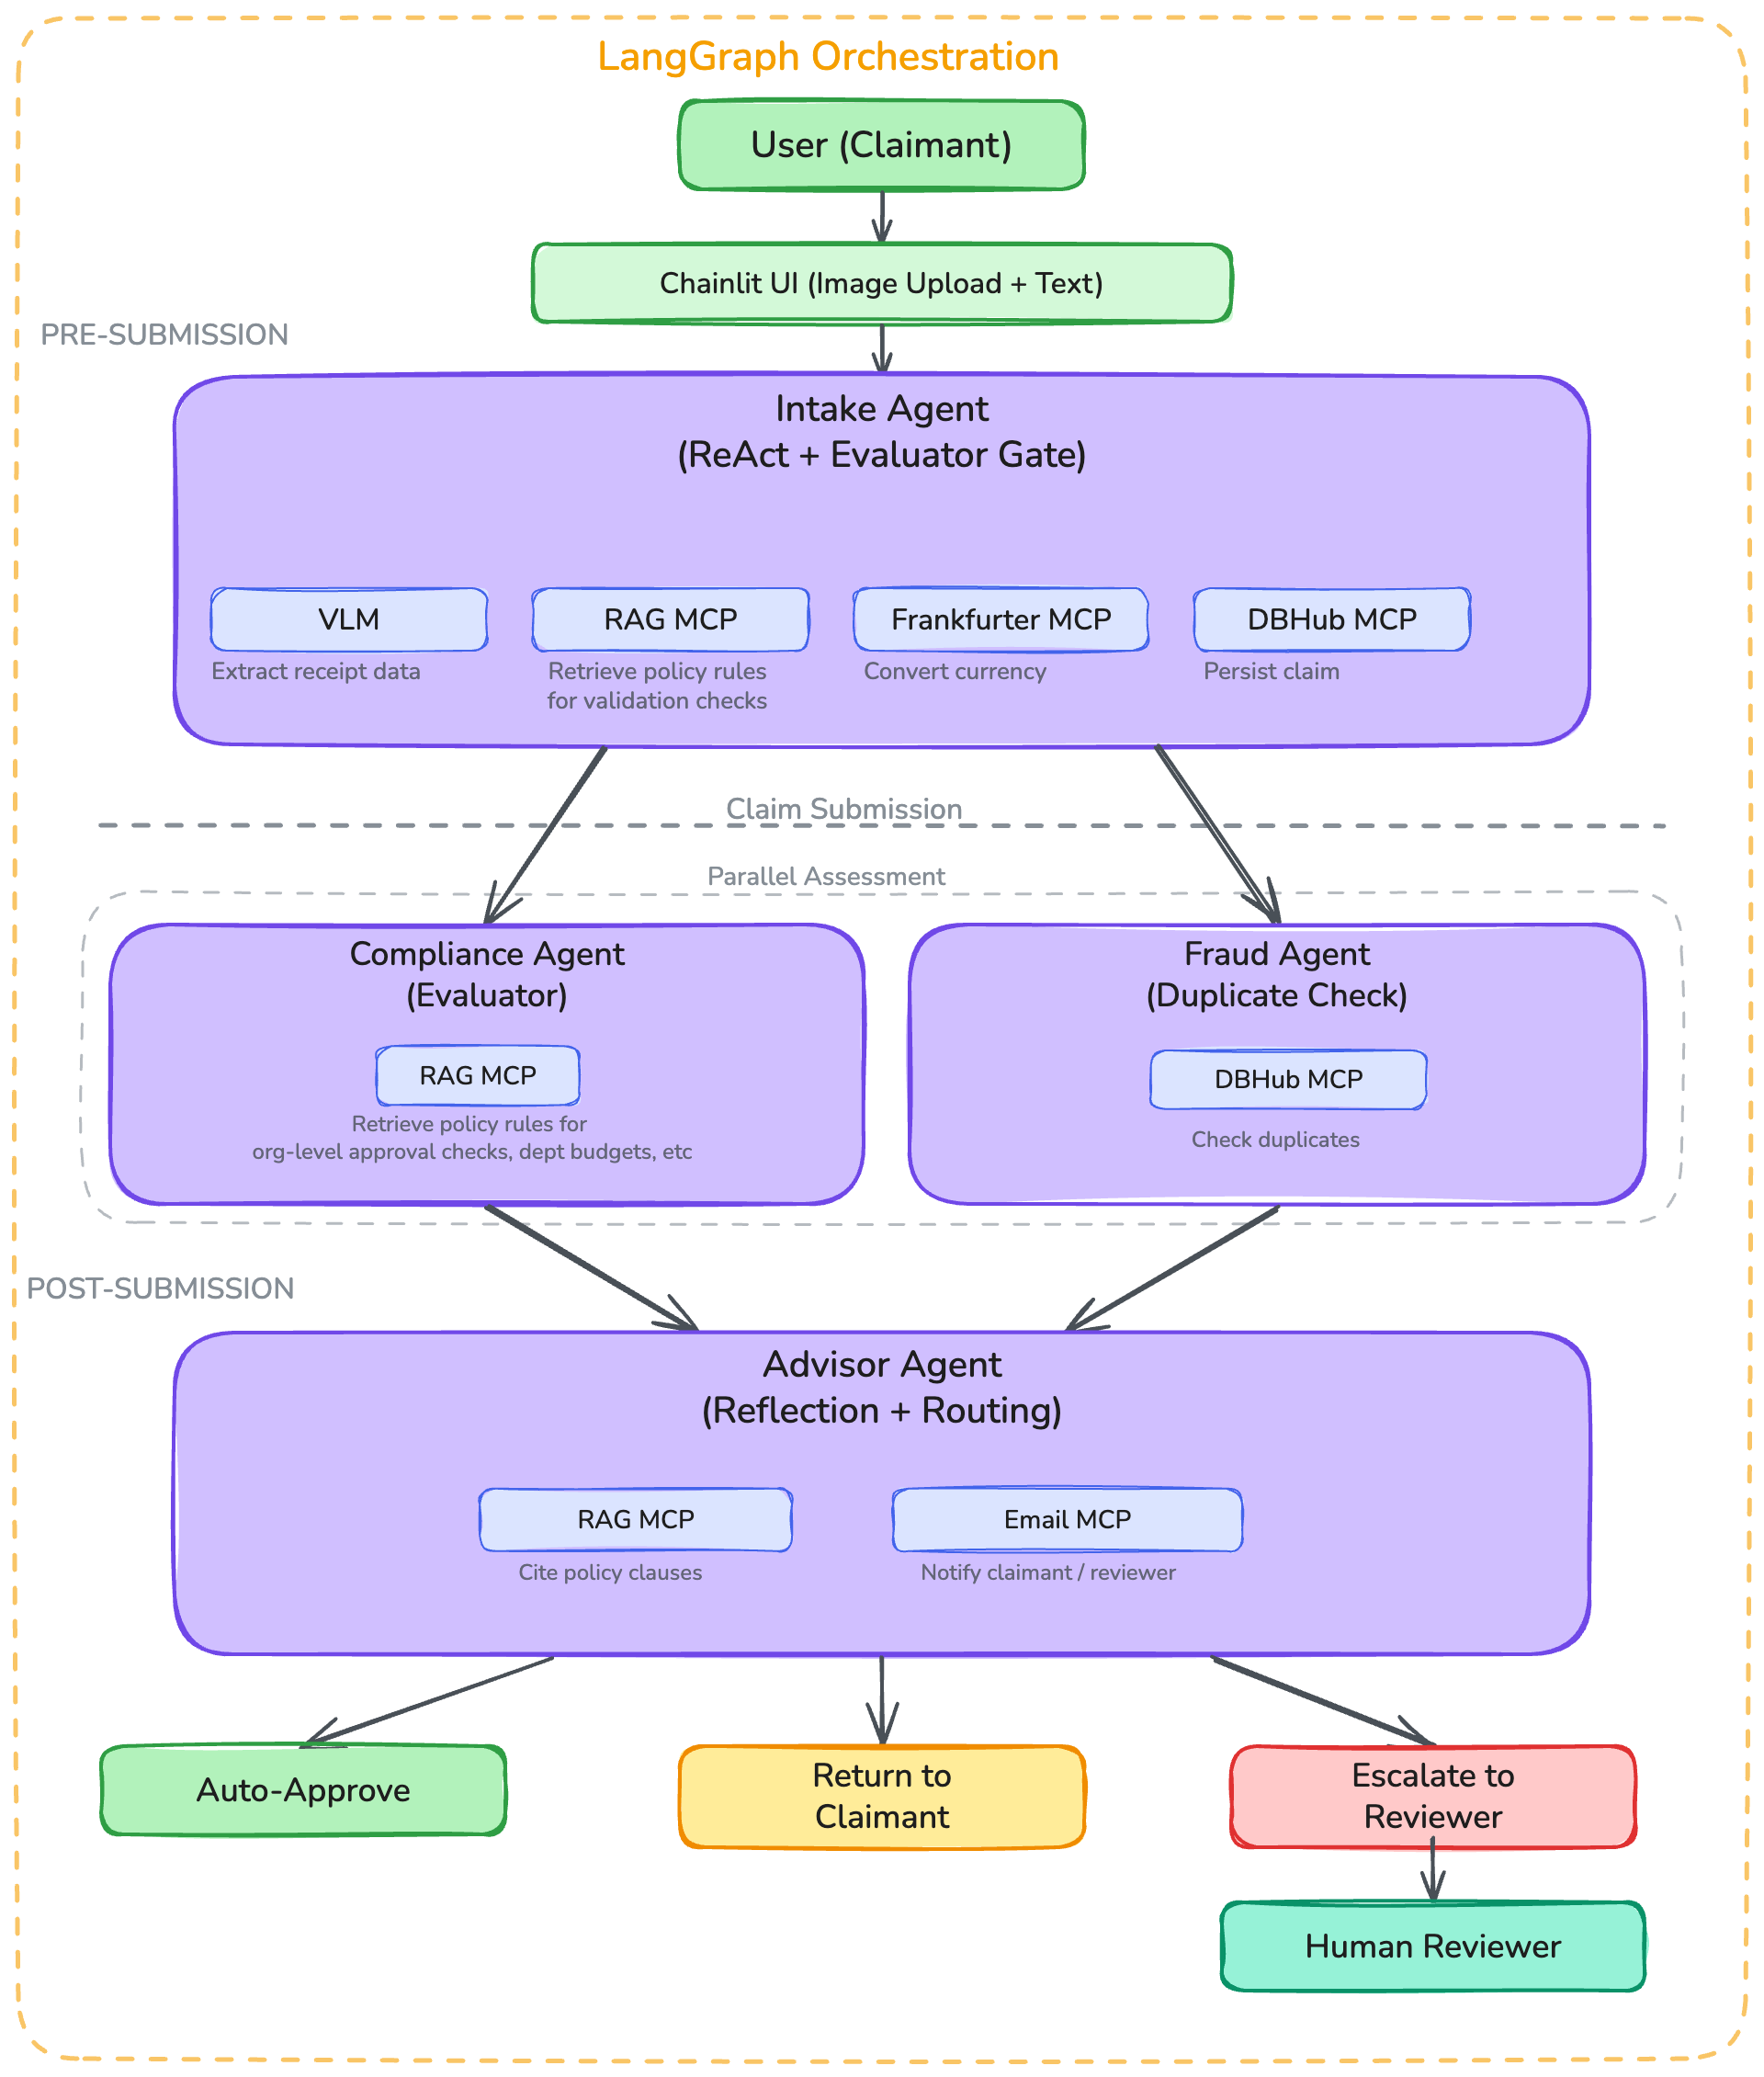
Figure 1: System diagram illustrating the stages in agentic expense workflow process,
along with the respective agents, patterns and integration types

